Year Group Overview: Year One
 | Autumn 1  8 weeks | Autumn 2  7 weeks | Spring 1  6 weeks | Spring 2  6 weeks | Summer 1  5 weeks | Summer 2  7 weeks
Texts/ Stimuli | Owl babies  Man on the moon | The storm whale  The snowflake  November night countdown- poem for trust | The tiger who comes to tea  Monkey do! (2 weeks) | In every house, on every street  School trip museum recount | The Giant jam sandwich  The Rainbow fish | George and The Dragon- Literacy shed  School trip recount Bridlington  School trip recount Sandal Castle  The Three little pigs
Magic of stories | Tom’s magnificent machines | Ron the royal guard | The Pandas who promised | The extraordinary gardener | The world needs the wonder you see | Little People, BIG DREAMS: Florence Nightingale by Maria Isabel Sánchez Vegara
Poems | My Body | Parts of the Body for Kids! | Jack Hartmann (Song) | The royal family by Sue Bleazard (Rhyme) | The seed- Out of the ark (Song) | Hot cross buns (Rhyme) | Seven continents | See You Later Alligator (Rhyme)
Phonics | 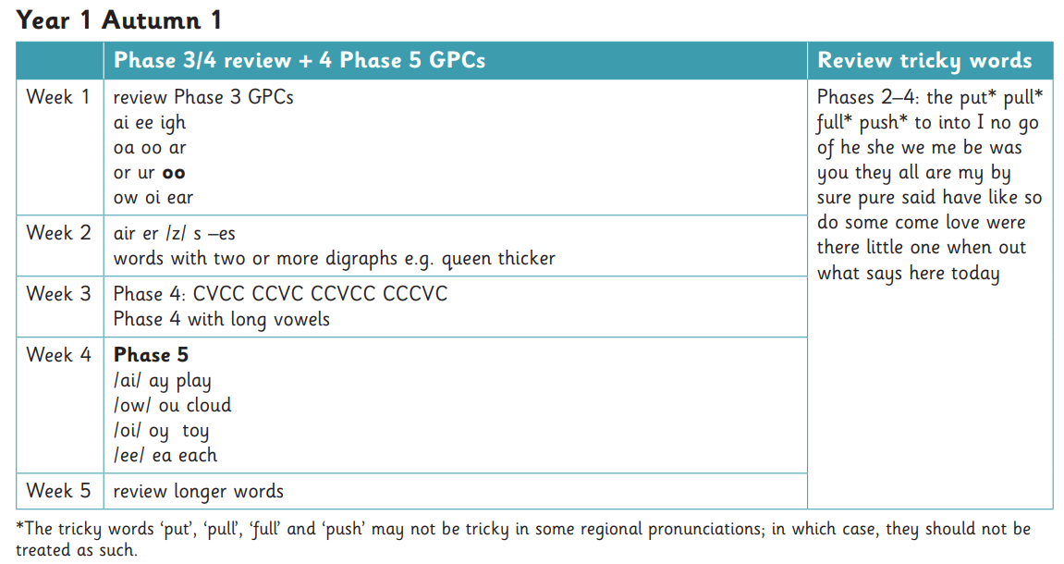 | 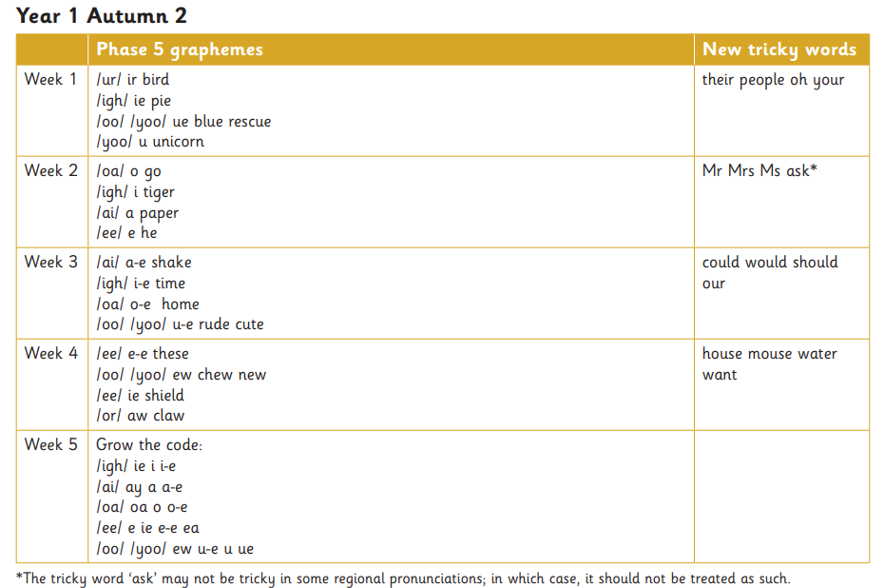 | 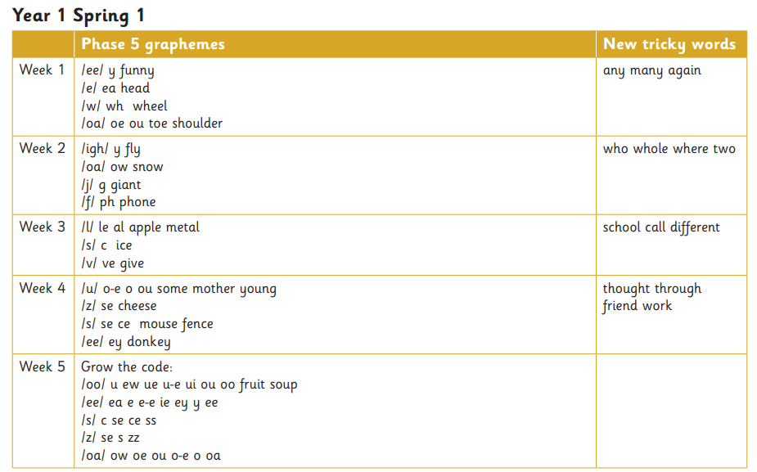 | 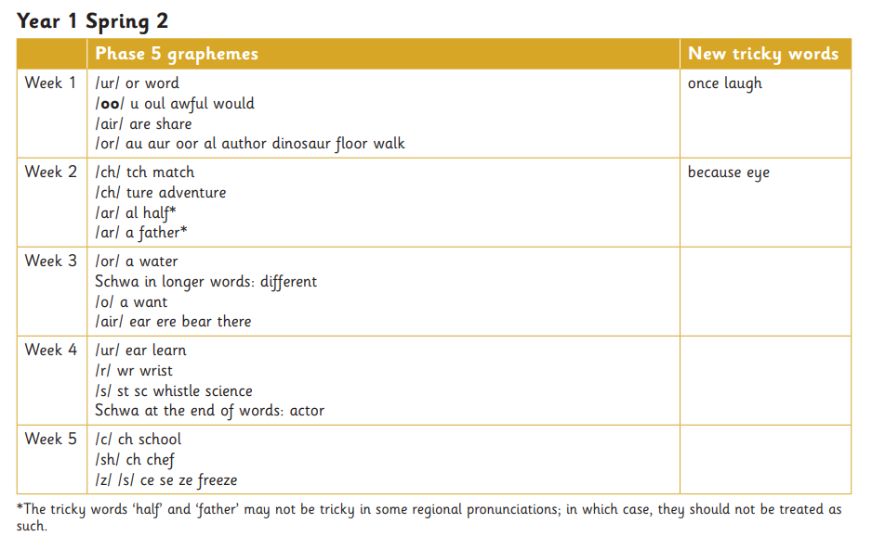 | 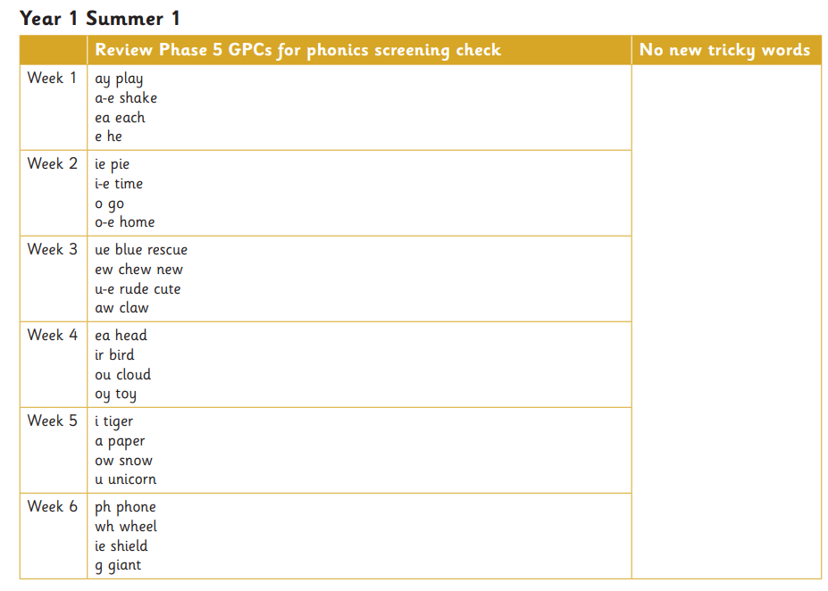 | 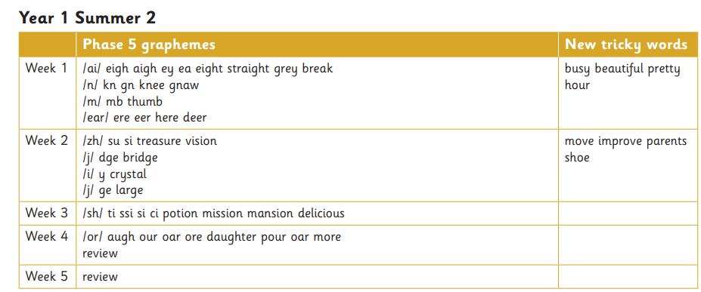
Spellings linked to phonics and the text | Owl babies:  Ambitious vocabulary:  Hunting  Brave  Swooped  - Mum  - Owl  - Sad  - Nest  - Log  - Tree  - Big  - Cold  - Black  - Bad  - Red  - Kind  ✏️ Sentences Using These Words  - The owls sat on a log  - Mum went off  - It is dark and big  - The nest is soft  - The big owl sat on a soft log.  - It was a dark, cold night.  - The little owl felt sad.  - They sat in a deep nest in the dark.  - The bad fox ran fast.  - The kind mum came back to the owls.  Man on the moon:  Ambitious vocabulary:  Rocket  Launch pad  Astronauts  Aliens  Picnic  Tourist  souvenirs  - man  - Bob  - moon  - job  - dust  - pack  - snack  - spot  - clean  - day (ay)  - play (ay)  ✏️ Sentences Using These Words  - Bob is a man on the moon.  - Bob can spot dust and clean it up all day long.  - Bob will pack a big snack.  - He enjoys his job each day.  - Bob will play at the end of the day.  - He wears boots to work.  - He went past the clouds in his rocket.  - The rocket will zoom up to the moon.  - He went in the bath after his trip to the moon. | The storm whale:  Ambitious vocabulary:  Shore  Distance  Wondered  Worried  Secret  Belonged  Review Words from Phases 3 & 4:  - boat  - sea  - wind  - fishing  - storm  - sand  - shell  - wave  - jump  - day (/ay/)  - beach (/ea/)  - whale (/wh/ focus)  ✏️ Sentences Using the Words  - The boat rocked on the sea.  - Noi went to the sea every day and had fun.  - The wind blew hard in the storm.  - He saw a fish and a bird.  - A shiny shell lay by the boat.  - A big wave crashed on the shore.  - The big whale was stuck!  - Noi put the whale in the bath.  - He saw the whale jump.  - The next day, the whale was gone.  - They sat on the beach together and had fun.  - Noi heard and saw the whale sing.  The snowflake:  Ambitious vocabulary:  Glistening  Twirled  Tumbling  Pleaded  Drifting  Whisked  Review: Phase 3 & 4 Words  - cold  - snow  - tree  - land  - star  - light  - gift  - went  - help  - wind  - blew  - winter  Phase 5 Autumn 2 Focus Sounds (Weeks 1–6)  - white (/wh/)  - day (/ay/)  - home (/o_e/)  - snowflake (/ow/)  - shine (/i_e/)  ✏️ Sentences Using the Words  - A cold wind blew from the sky.  - The soft snow fell and landed on to the ground.  - A snowflake landed on the tree.  - It dropped from the sky like a star.  - The girl saw it land by her window and smiled.  - The girl went out to look for snow and saw nothing.  - She wanted to help the snowflake.  - The white flake danced in the air.  - She ran home to show her snowflake.  - The tiny snowflake glowed like magic.  - The lights began to shine in the town.  - The snowflake was happy in its new home. | Week 1 to week 3:  The tiger who comes to tea:  Ambitious vocabulary:  Swallowed  Supper  Mouthful  teapot  - tea  - door  - eat  - cake  - boy  - girl  - tiger  - meat  - food  - chair  - drink  - paw  - cheeky  - blue  ✏️ Sentences Using the Words  - He rang the door bell and walked in for tea.  - I was shocked to see a tiger!  - He drank all the water and ate all the cakes.  - The tiger left and never came back.  Questions-  - Do you want a drink?  - Can we have some more cake?  - Will the tiger come back?  Instructions-  - Cut  - Half  - Spread  - Butter  - Jam  - First  - Next  - Now  Week 5/6-  Monkey do!  Ambitious vocabulary:  Mischief  Admires  Scram  crowded  Explanation marks  Past tense Ed endings, suffix ing, verbs  - Get in the post box!  - Get in the car!  - Stand on the chair!  - Get the cat down!  Stamp your feet!  Postman  Milkman  Monkey  Flowers  Shops  Skipping  Teacher  Children  Playground  Mum  Dad | In every house:  Ambitious words-  Wonky  Wobbly  Hunt  Slouch  Wonder  - Street  - House  - Living room  - Bedroom  - Kitchen  - Home  - Bathroom  - Family  - Never  - Toys  - Road  - Mirror  - Family  - Window  - Neighbours  - People  - On my street, I can see ten trees  - Some houses are small and some are tall.  - Every house has a door and a roof.  - The street is clean and quiet at night.  - My neighbour has a blue gate.  - My family live on a busy road  - On every street, children play games.  - Some homes have a garden with green grass.  In the kitchen we cook, but we never just cook. We talk at the table about our day.  In this room we sit on the sofa, but we never just sit. We watch tv and play games.  In this room we wash, but we never just wash. We brush our teeth and smile in the mirror.  In this room we sleep, but we never just sleep. We play with our toys and chill from the day. | The rainbow fish-  Ambitious words-  Ordinary  Glide  Shimmer  Emerged  Advice  Discover  Peculiar feeling  Whizzed  - fish  - sea  - deep  - blue  - wave  - water  - sand  - like  - little  - come  - shiny  - scales  - tail  - gold  - silver  - some  - were  - there  - looked  - wanted  - helped  - played  - shared  - asked  - smiled  - listened  The Rainbow Fish shared his shiny scales.  The little fish played in the deep blue sea.  The Rainbow Fish helped the little fish  They played near the rocks.  The Giant Jam Sandwich  Ambitious words-  Dived  Hummed  Nuisance  Suggestion  Squealed  Hitched  Feast  Wasps  Swarm  - Giant  - Sandwich  - Villagers  - Sticky  - Noisy  - Stuck  - A huge group of wasps came down the street.  - They stung his head and made him run.  - They made a great plan to trap the wasps.  - The baker said lets make a giant jam sandwich.  - The men bake a giant loaf in the hot oven.  - Boys and girls came to see the huge loaf.  - They spread sweet jam in the middle of the bread.  The wasps try to eat the jam but get stuck. | George and the Dragon  Ambitious words-  Mighty  Blast  Monstrous  Fierce.  Terrified  Pity  Draughty  Miserable  Loan  - Dragon  - George  - Mouse  - Brave  - Villagers  The dragon is bigger and braver than the other dragons.  George the mouse is the smallest and he is unafraid of the dragon.  The dragon has sharp claws and long wings.  George the mouse helps the villagers by doing the hardest jobs.  The dragon is unhappy when he sees the fires in the village.  George the mouse is quicker and stronger than he looks.  The dragon makes loud roars and snorts.  George the mouse gives the dragon boxes of food and water.  Three little pigs:  Ambitious words-  Beware  Afraid  Wise  Beady eyes  Snout  Bellowed  Scurried  Howled  The first pig made his house out of straw.  The next pig made his house out of sticks.  The last pig made his house out of bricks.  The wolf blew down the straw house and the pig ran to the next house.  The wolf blew down the stick house and the pig ran to the next house  Independent-  The wolf with sharp teeth came to the door to come in.  The wolf went on top of the strong roof and the pigs stayed inside.  The wolf got stuck in the chimney and went into ?  Seadside recount  Words level practice  Bridlington  Coach  Beach  Sand  Sea  Ice cream  Train  Bucket  Spade  Hat  Sandcastle  Lunch  Sentences:  We got on a coach to Bridlington.  The sand felt soft on my feet.  We had lots of fun on the sand and we used buckets and spades.
Oral composition | (Teacher modelling 3-5 simple sentences in the right order) | (Teacher modelling 3-5 simple sentences in the right order) | (Teacher modelling 3-5 simple sentences in the right order. Begin to model a compound sentence) | (Teacher modelling 3-5 simple sentences in the right order. Begin to model a compound sentence) | (Teacher modelling a mixture of compound and simple sentences in the right order) | (Teacher modelling a mixture of compound and simple sentences in the right order)
Year 1 Writing progression of skills | - 3 and 4 sound words using sounds taught so far  - Hear sounds in words using segmenting fingers to help with writing 3 and 4 sound words  - Dictate 3-5 simple sentences using the sounds taught so far  - Sentences start with a CL and end with a FS  - Understand words as individual units with finger spaces  - Letters formed and orientated correctly | - 3-5 sound words using sounds taught so far  - Hear sounds in words using segmenting fingers to help with writing 3-5 sound words  - Dictate 3-5 simple sentences using the sounds taught so far  - Sentences start with a CL and end with a FS  -Introduce conjunction ‘and’  - Understand words as individual units with finger spaces  - Letters formed and orientated correctly  - Writing sentences independently | - 3-5 sound words using sounds taught so far  - Hear sounds in words using segmenting fingers to help with writing 3-5 sound words  - Dictate 3-5 simple sentences using the sounds taught so far  - Sentences start with a CL and end with a FS  - conjunction ‘and’  - Personal pronoun ‘I’  - Understand words as individual units with finger spaces  - Letters formed and orientated correctly  - Writing sentences independently  - Question mark  - Exclamation mark | - short, medium and multisyllabic words using sounds taught so far  - Hear sounds in words using segmenting fingers to help with writing words  - Dictate 3-5 simple sentences using the sounds taught so far  - Sentences start with a CL and end with a FS  - conjunction ‘and’  - Personal pronoun ‘I’  - Capital letters for people and places  - Understand words as individual units with finger spaces  - Letters formed and orientated correctly | - Independently orally rehearse and sequence sentences to form short narratives  - short, medium and multisyllabic words using sounds taught so far  - Hear sounds in words using segmenting fingers to help with writing words  - Dictate 3-5 simple sentences using the sounds taught so far  - Sentences start with a CL and end with a FS  - conjunction ‘and’  - Personal pronoun ‘I’  - Question mark  - Exclamation mark  - Capital letters for people and places  - Understand words as individual units with finger spaces  - Letters formed and orientated correctly  - Writing sentences independently | - Independently orally rehearse and sequence sentences to form short narratives  - short, medium and multisyllabic words using sounds taught so far  - Hear sounds in words using segmenting fingers to help with writing words  - Dictate 3-5 simple sentences using the sounds taught so far  - Sentences start with a CL and end with a FS  - conjunction ‘and’  - Personal pronoun ‘I’  - Question mark  - Exclamation  mark  - Capital letters for people and places  - Understand words as individual units with finger spaces  - Letters formed and orientated correctly  - Writing sentences independently
Grammar and spelling | Nouns  Adjectives | Nouns  Adjectives  Plural suffix s es  Suffix ing | Nouns  Adjectives  Past tense suffix ed  Suffix ing | Nouns  Adjectives  Verbs | Nouns  Adjectives  Verbs  Past tense suffix ed  Suffix ing  Suffix er est | Nouns  Adjectives  Verbs  Prefix un  Suffix er est  Plural suffix s es
Spelling shed | Words ending with ff, ll, ss, zz or ck | Adding ‘-s’ or ‘-es’ to make plurals | Adding the suffixes ‘-ing’ and ’-ed’ |  |  | Adding the prefix ‘un-’ and the suffixes ‘-er’ and ‘-est’
Must haves | Leaving spaces between words  Letter formation and orientation | Leaving spaces between words  Use a capital letter  Using full stops  Letter formation and orientation |  |  | Skills for simple sentences  Using capital letters for people and places  Using conjunction ‘and’ | Skills for simple sentences  Using exclamation and question marks correctly  Capital letter for ‘I’  Using conjunction ‘and’

