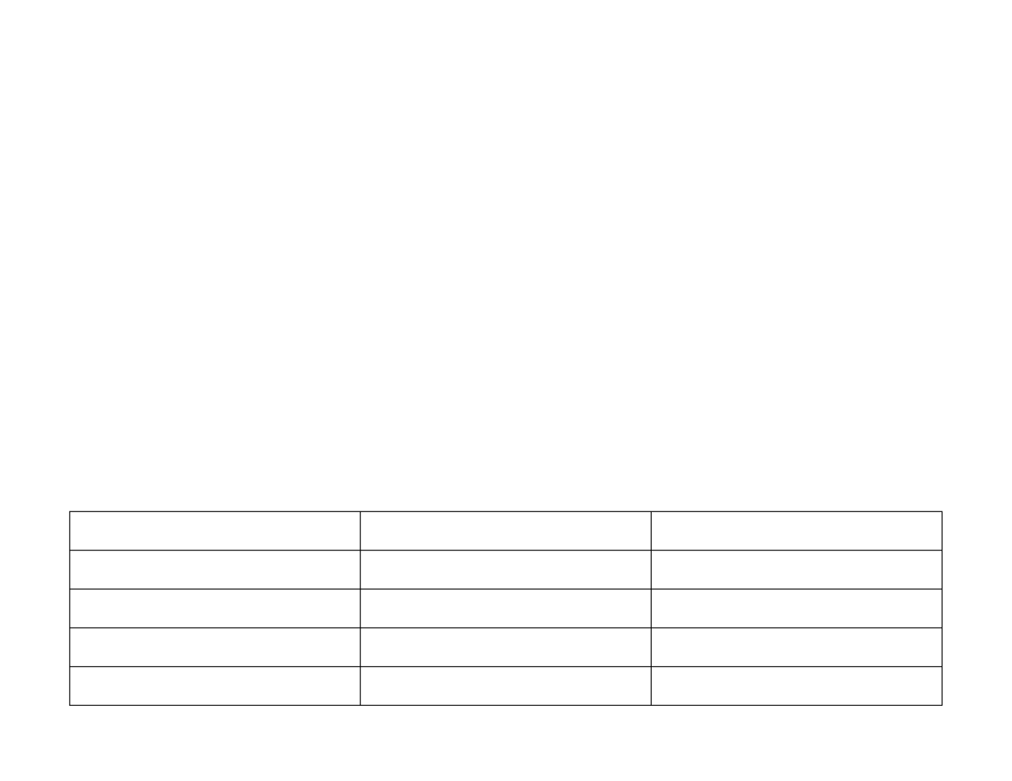

REVIEW DATE:

Sept 2027

SIGNED OFF BY:

C Elliott

Helen Smaile

ROLE:

Headteacher

Chair of Governor

LEAD PROFESSIONAL:

Megan Hollis

C Elliott

STATUS:

Statutory

SEND POLICY 2026
-
2027

Aims and Objectives
The staff and governors of Sandal Magna Community Academy aim to provide a broad and balanced curriculum for all children; that includes setting suitable learning challenges, responding to pupils’ diverse learning needs and overcoming potential barriers to learning and assessments. We believe that every child matters and should be supported to make the best possible progress during their time with us.

The Governing Body and teaching staff will do their best to ensure that the necessary provision is made for any pupil who has SEND (Special Educational Needs and Disabilities) and ensure that, where the Headteacher or the appropriate governor has been informed by the LA (Local Authority) that a pupil has SEND, those needs will be made known to all who are likely to teach them. All of our teachers are teachers of SEND and understand the importance of recognising and providing appropriate support for barriers that children may face.

Our Executive Head, Head of School, SENCo and Governing Body will ensure an ‘Information Report’ is updated annually and posted on the school’s website to outline the provision we can offer and to answer any questions that parents may have.

Our staff will ensure that pupils with SEND join in the activities of the school, together with pupils who do not have special educational needs and disabilities, so far as that is reasonably practical and compatible with the pupil receiving the necessary special educational provision, the efficient education of other children in the school and the efficient use of resources.

This policy complies with the statutory requirements in the SEND Code of Practice: 0 - 25 (2015) and should be read in conjunction with the following guidance, information and policies:
- The Equality Policy
- The Accessibility Plan
- The school’s SEN Information Report
- The LA Guidance – ‘Children & Young People with SEN; Guidance – School Based Support’
- Statutory Guidance on Supporting Pupils at School with Medical Conditions (April 2014) • The Safeguarding Policy

In accordance with the overarching principle of the new Code of Practice, this policy has been co-produced with: The School Leadership Team, SENCo and the school Governing Body.

Responsible Persons
The ‘responsible persons’ for SEND are the Headteacher, Chair of Governors and the SEND Governor.
The person co-ordinating the day-to-day provision of education for pupils with SEND in the mainstream setting is the Special Educational Needs Co-ordinator (SENCo). Class Teachers play an important part in overseeing, monitoring and reviewing the needs of all the children in their care, including those with SEND.

Partnership with Parents
We value the opinions and expertise that our parents bring and we welcome support and guidance as we realise and understand that no one knows a child better than their parents. We believe that successful and effective provision is put in place, and therefore the most progress is achieved, when school and home work alongside one another to form a strong partnership that is consistent and takes into account the views of all concerned.

The school will actively seek the involvement of parents in the education of their child and will meet with parents regularly to discuss progress, outcomes and general school issues that may arise during the year. Parents will always be kept informed about the needs experienced by their children and the provision that is being put in place in accordance with the recommendations outlined in the new Code of Practice. This could be in the form of attending an Annual Review meeting for children who have an Education Health and Care Plan (EHCP) in place or a termly review of a child’s ‘Supporting Me to Learn Plan’. However, we invite parents to arrange a meeting with their child’s teacher or the SENCo at any time if they have any issues or concerns or would just like an update on how their child is doing in school.

Communications between the parent and the school will be consistently maintained. Parents will be informed as to how our school contributes to the ‘Local Offer’ and key information will be published on the school’s website.

Pupil Participation
At Sandal Magna, we take a ‘Person Centred Approach’ and understand that the individual child’s voice is paramount in our decisions and in our implementation of provision and support. We encourage all children, where possible, to take an active role in discussions with school, parents and outside agencies in order for their views and wishes to be considered and understood by all parties involved. We will also work to ensure, where appropriate, that pupils are fully aware of their individual needs and the targets outlined in their One Page Profile, Supporting Me to Learn Plan, My Support Plan or Education Health and Care plan.

Admissions and Inclusion
All teachers in our school are teachers of children with SEND. As such we adopt a 'whole school approach' to special educational needs and disabilities, which involves all staff adhering to a model of good practice. We are committed to identifying and providing for the needs of all children in a wholly inclusive environment. Inclusion is regarded as crucial to the policy, in line with that of the Local Authority.

When a child starts at our school the parents/carers fill in details of medical history, which could alert the school to potential problems. Parents and carers are also asked if they are happy with their child’s development, language skills and general health and physicality. We also ask for details of any external agencies already involved with the child.

The school operates an equal opportunities policy for children with SEND who are afforded the same rights as other children. This includes children with an Education and Health Care plan (EHCP), along with others who have less significant special educational needs/disabilities, but may have a One Page Profile, a Supporting Me to Learn Plan, a My Support Plan or be involved in interventions to support their needs.
The admission arrangements for all pupils are in accordance with national legislation, including the Equality Act 2010. This includes children with any level of SEN; including any child with an Education, Health and Care plans.
All SEN paperwork should be passed to our SENCo, Megan Hollis, by any previous setting or parents, as soon as possible. If the child is making a transition from another school, a meeting may be set up between the feeding school to aid the smooth transition of the pupil, and discuss arrangements to be made as well as any other important information relating to that child’s needs. Where face to face meetings are not possible, contact will be made via telephone to ensure that there is a good understanding of what type of provision is required.
We will do our best to ensure that the necessary provisions and preparations are made prior (where possible) to the child starting with us. The child will be closely monitored from the start to ensure that all the appropriate provisions are in place.

Access to the Curriculum
The National Curriculum will be made available for all pupils wherever possible. Where pupils have SEND the school will make full use of classroom and school resources, and may also request support from external agencies, to ensure children can access the curriculum or alternative learning.

The school will make provision for pupils with SEND to match the nature of their individual needs and the class teacher and SENCo will keep regular records of the pupils’ special educational needs, the action taken and the outcomes. There will be flexible groupings of pupils so that learning needs may be met in individual, small group or whole class contexts.

The curriculum will be differentiated to meet the needs of individual pupils. Teaching styles and flexible groups will reflect this approach. Schemes of work for pupils, within classes and year groups, will reflect whole school approaches to teaching and learning and will take account of special educational needs. A ‘One Page Profile’ will be devised for minor SEND needs, which outlines the child’s individual needs and provision that will need to be in place for them. This will be reviewed at least annually but sooner if necessary. Following on from this, any child presenting with a higher level of SEND will have a ‘Supporting Me to Learn Plan’. This ‘person centred’ approach will ensure school and home recognise the child’s strengths and areas of difficulty, likes and dislikes and highlight any barriers to learning. Targets will be set and reviewed at least termly, finely graded to ensure that they experience success. Alternatively some children will receive targeted support via specific interventions or ‘Booster’ sessions.

We support children in a manner that acknowledges their entitlement to share the same learning experiences that their peers enjoy. However, there are times when, to maximise learning, we ask the children to work in small groups, or in a one-to-one situation outside the classroom.

Providing a Graduated Response
The class teacher informs the parents at the earliest opportunity to alert them to concerns and enlist active help and participation. The class teacher identifies a child with special educational needs when the child;

· Makes little progress when teaching approaches are targeted particularly in a child’s identified area of weakness.

· Shows signs of difficulty in developing literacy or numeracy skills which result in poor attainment in some curriculum areas.

· Presents persistent or behavioural difficulties which are not improved by the management techniques employed in the school.

· Has sensory or physical problems and continues to make little or no progress.

· Has a communication and/or interaction difficulty despite the provision of a differentiated curriculum.

The school offers a differentiated curriculum. When a pupil fails to make progress and shows signs of difficulty in some of the areas mentioned the school will make a record of this, and the child will be placed on the school’s SEND register. Support that is additional to and different from the differentiated curriculum, will be provided through a range of strategies including;

- Classroom organisation and management

- In-class support by teacher/teaching assistant

- Withdrawal for individual/small group work to follow interventions

- Behaviour modification programmes

- Use of specialist equipment / resources

- Alternative teaching strategies including the use of ICT.

The resources allocated to pupils who have SEND will be deployed as appropriate, as outlined in the revised Code of Practice.

Parents and pupils (where possible) will be informed and involved in decisions taken at this stage. If a pupil does not make progress despite the school taking the action outlined, advice will be sought from the appropriate support services, and a ‘My Support Plan’ may be devised to help the child. The ‘Supporting Me to Learn Plan’ will continue to be reviewed termly and will feed into the larger targets set out in the ‘My Support Plan’, which will be reviewed annually.

If progress is still not achieved, the child may be assessed bearing in mind the authority’s criteria with a view to initiating a statutory assessment of special educational needs under the 1996 Education Act. This might lead to an ‘Education and Health Care’ plan (EHCP). The appropriate forms will be used for recording a referral as necessary. The EHCP will be formally reviewed on an annual basis, with all the professionals involved with the child, along with the child and their parents/guardians. The child’s ‘Supporting Me to Learn Plan’ will continue to be reviewed on a termly basis and will be used to inform the EHCP at the next Annual Review.

Identification and Assessment
Identification of children with SEND will be undertaken by all staff, and through the SENCo, and appropriate records will be maintained. Records will be developed through a process of continuous assessment by the class teacher or as a result of standardised tests of educational achievement administered by the class teacher together with end of Key Stage attainment tests if deemed appropriate. Children are added onto the SEN Register if they are making limited or no progress for a sustained period of time (where attendance or other contextual circumstances are not a reason for this)

Some children on the SEN Register will be tracked on Insight to show their attainment and progress however, it may be necessary to use the PIVATS to track the progress and attainment of some of our SEND children so that smaller steps of progress can be recognised and recorded.

Assessments allow the pupil to show what they know, understand and can do, as well as to identify any learning difficulties.

Where necessary, pupils will be referred to outside agencies via the SENCo for diagnostic testing to construct a profile of the child’s strengths and areas of need. The Educational Psychology Service also works closely with school to support and advise us on behavioural difficulties and other complexities. The progress of children with SEND will be reviewed through formative and summative assessments and discussed regularly at termly Pupil Progress Meetings led by the headteacher and half-termly meetings for teachers and teaching assistants led by the SENCO.

Assessments may include:
- Foundation Stage Profile (Nursery and Reception Class)
- Half termly assessments in Reading, Writing and Maths (KS 1 and 2)
- SATs (if taken)
- The regular administration of informal reading inventories (designed to provide a profile of reading achievement)
- Phonic check-lists
- Records of work
- Results of standardised and diagnostic tests (e.g. from SaLT or LSS)
- Behaviour charts if appropriate
- Observations made by teacher / teaching assistant / other members of staff
- Pupil comments / opinions on progress (where appropriate)
- PIVATS for some children whose progress or attainment deems this as an appropriate resource to use.

Resources
The school is allocated delegated funds for pupils with SEND. School also receives ‘top-up’ funding for children with more severe learning or behavioural needs and/or disabilities. These funds are devoted to the purchase of extra support and resources. The school supplements this with money from the base budget as and when it is appropriate. The governing body will use the principles / criteria in the Code of Practice to guide them in the allocation of resources. These will include:

- The placement of pupils on My Support Plans or EHC Plans.
- Results of standardised and diagnostic tests
- SATs results if applicable
- Teacher assessments
- Recommendations from other agencies working in partnership with the school
e.g. Behaviour Support Service, Educational Psychology Service, SEN Support Service

Liaison
Parents will be informed before an external agency becomes involved with their child. Liaison with external agencies supplements the support and assessment of the needs of individuals. Regular liaison is maintained with a range of external agencies for pupils on Support Plans and pupils with an EHC plan or Statement. Some of these services include;

- SEN Support Services
- WISENDSS
- CAMHS
- Future in Mind
- Educational Psychological Service
- Speech & Language Therapists
- Occupational Therapists
- Service for the Hearing Impaired
- Service for the Visually Impaired
- Health Service
- Welfare Service
- Social Service
- Pre-5 Service
- REACH Team (Looked after children)
- SENART (Special Educational Needs Assessment and Review Team)

The school has links to other schools and liaison is maintained particularly with regard to transition issues.

Staff Development
In-service training needs related to SEND will be identified by the Headteacher in consultation with the SENCo and staff.

Evaluating Success
This school policy will be kept under regular review. Evidence will be gathered regarding:

- Staff awareness of individual pupil need
- Success of the identification process at an early stage
- Academic progress of pupils with SEND
- Improved behaviour of the children, where this is appropriate
- Number of exclusions
- Number of children supported by the funding allocation
- Consultation with parents
- Number of pupils requiring support from external agencies
- Pupils’ awareness of their targets and achievements.
- The school meets the statutory requirements of the new Code of Practice

The Able Child
The school is aware that children with special abilities in whatever area are also regarded as having special educational needs and as such will receive a differentiated curriculum within the classroom environment. At times it may be deemed appropriate for a gifted and talented child to be taught in a different class, or set, for certain areas of the curriculum. This will be done after consultation with the SENCo, parents of the child and the child, and is subject to review.

This policy is a working document and therefore is open to change and restructuring as and when the need arises.

(September 2026)

