Nursery Journey

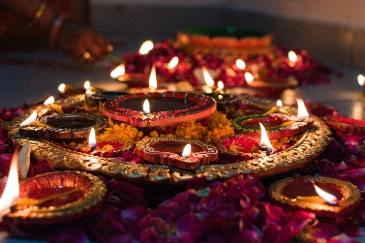
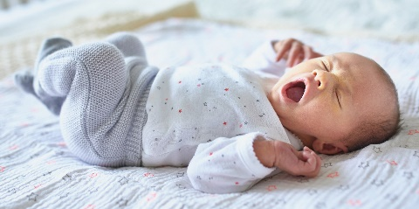
Autumn

Changes Over Time
Children will observe and talk about where they live and who they live with. They will discuss how this has changed over time.
Now and Then
Children will compare celebrations from the past, within their life, with current celebrations.

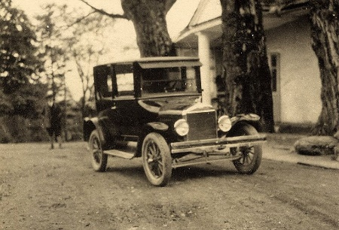
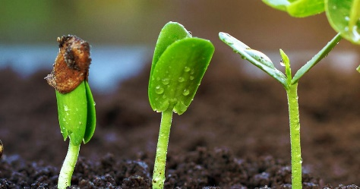
Spring
Changes Over Time
Children will spot how and discuss how vehicles have changed over time.
Changes Over time
Children will use their science links to notice how plants change over time from a seed.

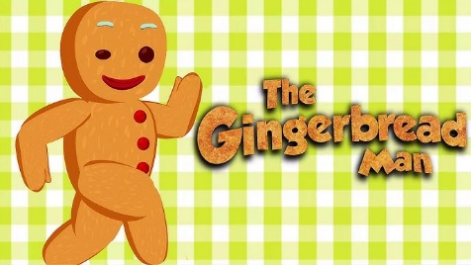
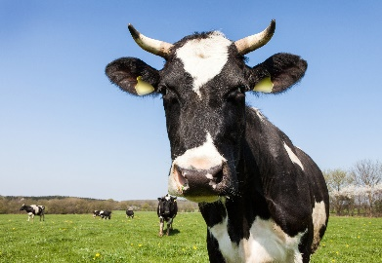
Summer
Changes Over Time
Children will consider how animals change over time, looking at their physical changes like their height.
Changes Over time
Children will sequence familiar stories using language of time.

Reception Journey

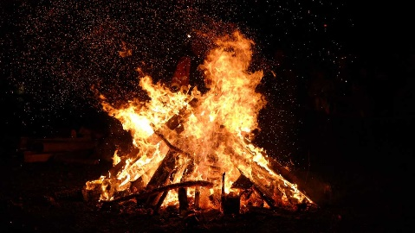
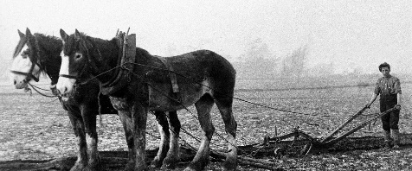
Autumn

Changes Over Time
Children will consider how harvest, and farming, have changed over time.
Events before we were Born
Children will discover the meaning of Bonfire Night.

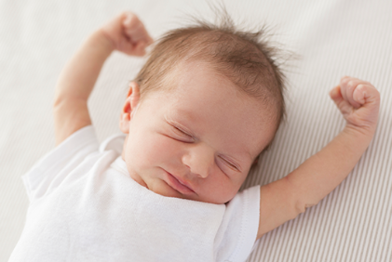
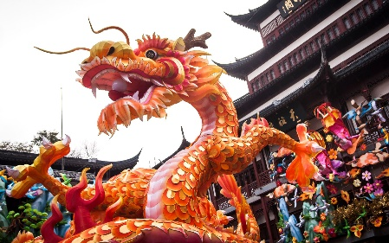
Spring

Now and Then
Children will look at ways celebrating the Chinese New Year have changed.
Changes Over Time
Children will look at simple lifecycles and discuss how animals have changed during the lifecycle.

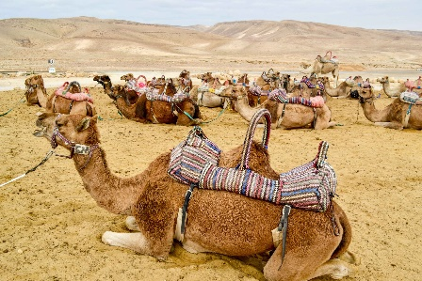
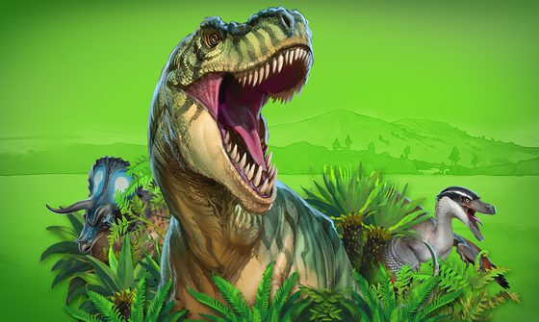
Summer

Events before we were Born
Children will share an interest in dinosaurs, discovering who roamed the earth before us!
Changes Over Time
Children will discuss how desert travel has changes across time.

Year 1 Journey
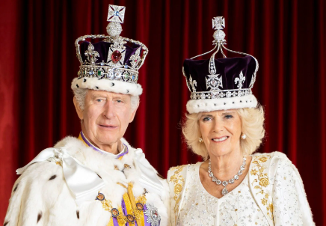
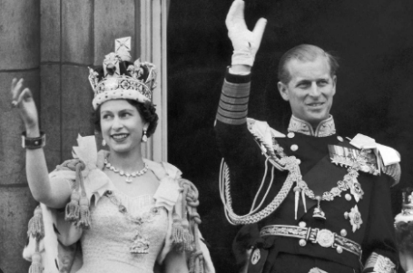
Autumn
The Royal Family
- Enquiry Question – Who are the Royal family and why are they important to Britain?
Curriculum Pillar – Hierarchy and Power

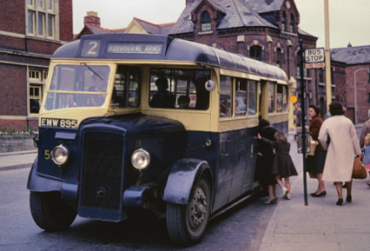
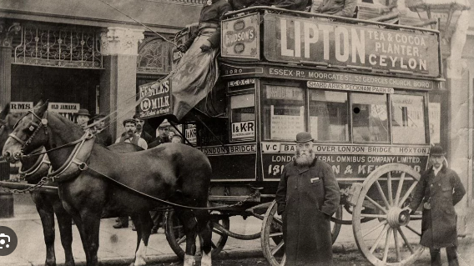
Spring
Travel & Transport
- Enquiry Question – How has transport changed over time?
Curriculum Pillar – Hierarchy and Power

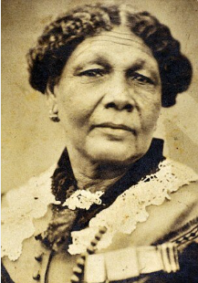
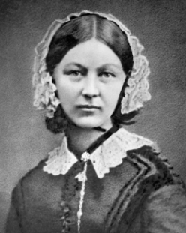

Summer

Nurturing Nurses (significant people)
- Enquiry Question – How have Florence Nightingale and Mary Seacole helped and influenced nursing and hospitals today?
Curriculum Pillar - Civilisation

Year 2 Journey
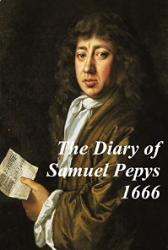
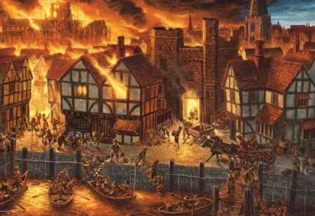

Autumn
The Great Fire of London
- Enquiry Question – Why did the Great Fire of London cause so much damage and what happened as a result?
Curriculum Pillar – Settlement
- Civilisation

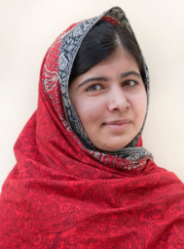
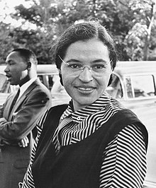

Spring
Fighting Injustice (significant people)
- Enquiry Question – How have the courageous acts of Rosa Parks and Malala Yousafzai changed our world and inspired others?
Curriculum Pillar – Civilisation
- Hierarchy and Power

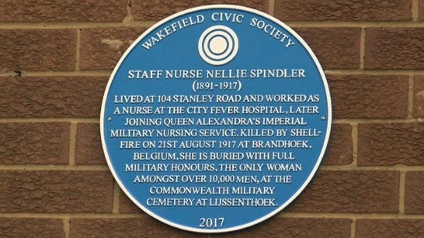
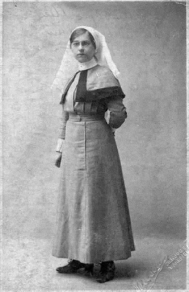
Summer
Local History: Nellie Spindler
- Enquiry Question – Who do we remember in Wakefield and why?
Curriculum Pillar –
- Civilisation

Year 3 Journey

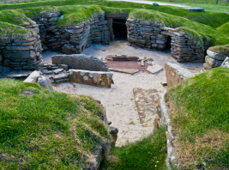
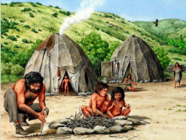
Autumn

Pre-historic Britain – Stone Age
- Enquiry Question – How did pre-historic people live and how did their lives change and evolve over time?
Curriculum Pillars – Settlement
- Civilisation
- Technological Advancements

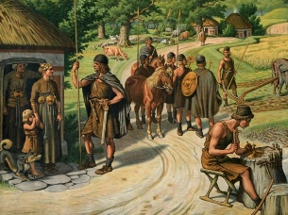
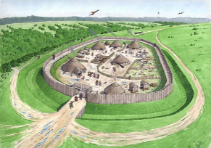

Spring
Pre-historic Britain – Bronze Age to Iron Age
- Enquiry Question – How did pre-historic people live and how did their lives change and evolve over time?
Curriculum Pillars – Settlement
- Civilisation
- Technological Advancements

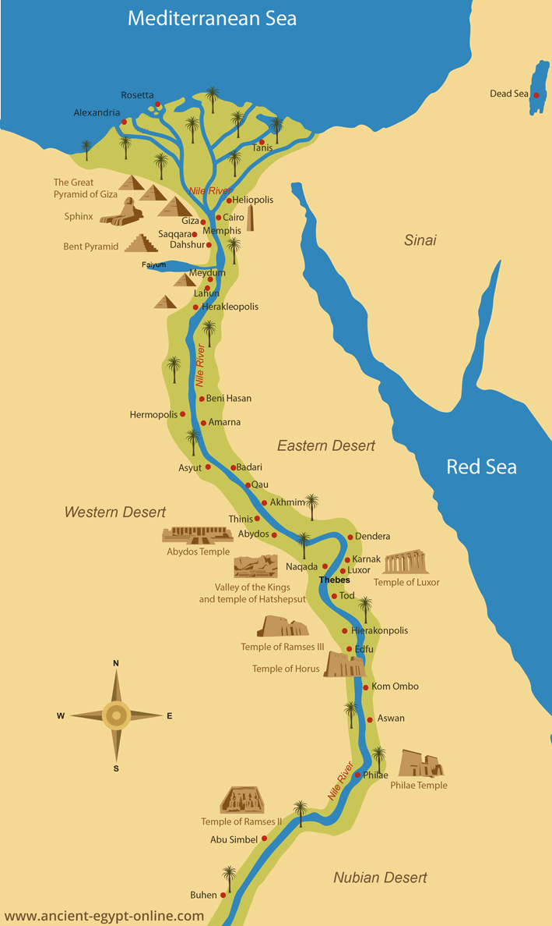

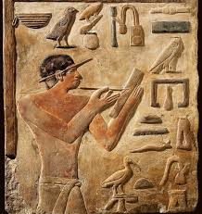
Summer
Ancient Egypt
- Enquiry Question – Why was the civilization of Ancient Egypt so successful?
Curriculum Pillars – Settlement
- Civilisation
- Hierarchy and Power
- Trade

Year 4 Journey
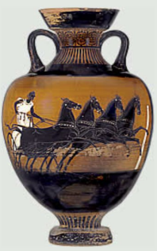
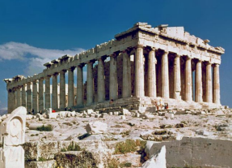
Autumn

Ancient Greece
- Enquiry Question – Why is ancient Greece considered to be so influential to the modern world?
Curriculum Pillars – Settlement
- Civilisation
- Hierarchy and Power
- Trade
- Technological Advancements

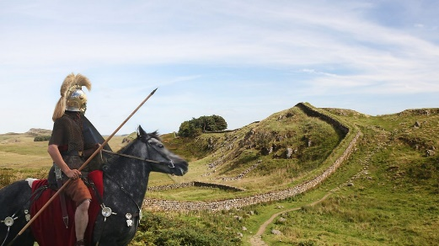
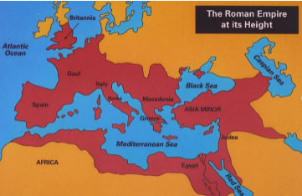
Spring
Roman Britain
- Enquiry Question – How did the Romans impact Britain?
Curriculum Pillars – Settlement
- Civilisation
- Hierarchy and Power
- Trade
- Technological Advancements

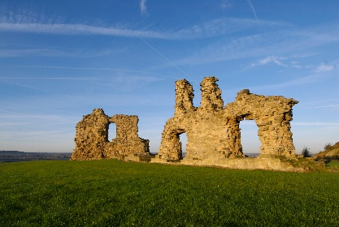
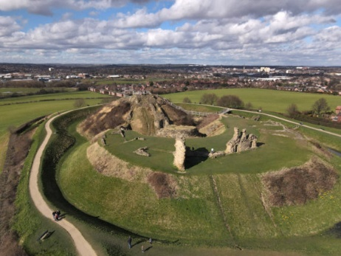
Summer
Local History: Sandal Castle
- Enquiry Question – Why was Sandal Castle significant to Medieval England?
Curriculum Pillars - Settlement
- Civilisation
- Technological Advancements

Year 5 Journey
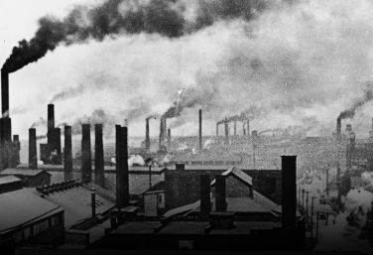
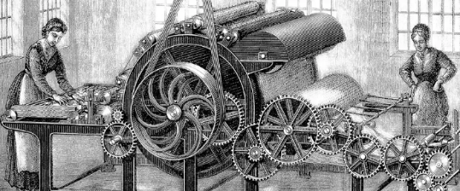
Autumn
Industrial Revolution
- Enquiry Question – What happened during the Industrial Revolution and how did Britain change?
Curriculum Pillars – Settlement
- Civilisation
- Technological Advancements
Industrial Revolution
- Enquiry Question – What happened during the Industrial Revolution and how did Britain change?

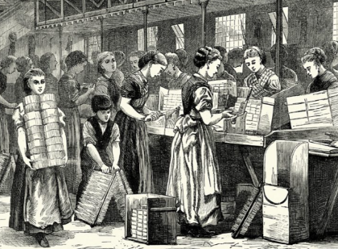
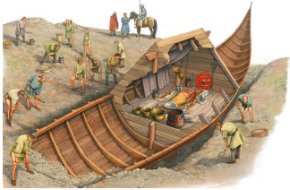
Spring

Anglo-Saxons
- Enquiry Question – Who were the Anglo-Saxons and how did they change Britain?
Curriculum Pillars - Settlement
- Civilisation
- Hierarchy and Power

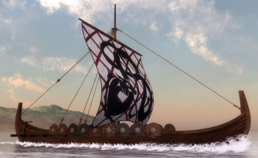
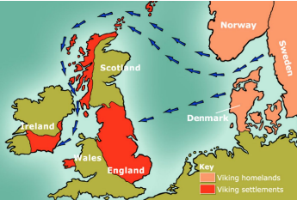
Summer
Vikings
- Enquiry Question – Who were the Vikings and how did they change Britain?
Curriculum Pillars - Settlement
- Trade
- Hierarchy and Power
- Technological Advancements

Year 6 Journey
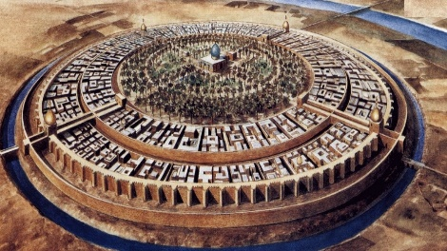
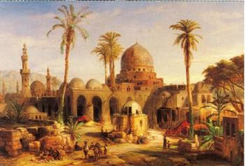
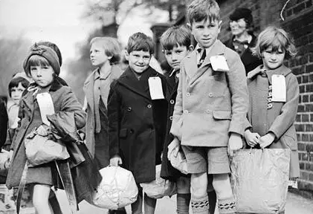
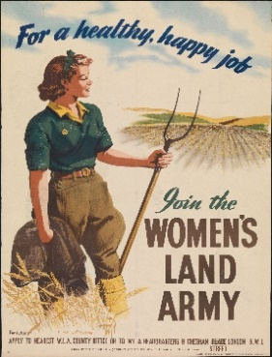
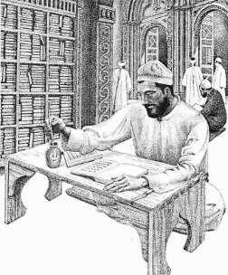
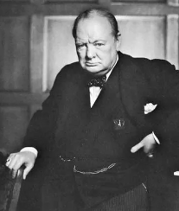
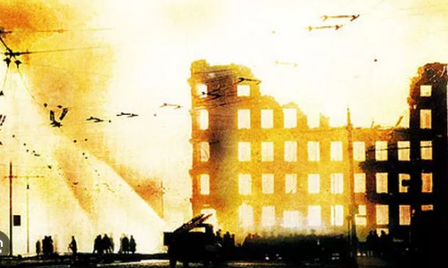
Islamic Civilisation
- Enquiry Question – What impact did early Islamic civilization have on the modern world?
Curriculum Pillars – Settlement
- Civilisation
- Technological Advancements
- Trade

World War II
- Enquiry Question – How were the lives of British citizens impacted during and after the Second World War?
Curriculum Pillars – Settlement
- Hierarchy and Power
- Civilisation
- Technological Advancements

Spring & Summer
Autumn & Spring

